Least privilege

Account types

Guest accounts: external, very temporary

User accounts: staff, people who have to interact with the account

Service accounts: external vendors/services (like discord bots)

Privileged accounts: accounts with admin permissions

User audits

Usage audit: To see if users are doing things they are supposed to

Privilege audit: To prevent privilege creep, bring person’s permissions back to PoLP

Account change audit: To check if the changes being made to the account are valid

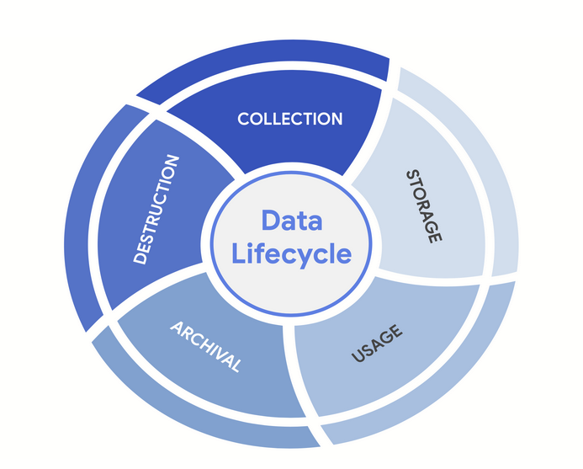

Vulnerabilities and controls are synthesized based on these stages. The CIA principle must apply in all of the stages.